Physical Education Lesson for the Week of April 13th
- Review the Muscle of the Month for April using the Slides attached – Show the pictures, explain what it’s used for and Try to perform an exercise using your pushing muscles (ex: pushing a chair, washing a window or car, hugging someone, etc.)

- Each Day During April continue to perform the activities on that specific day using your April activity calendar attached.

- Click the link below for a short workout video
https://www.youtube.com/watch?v=oc4QS2USKmk
***Reminder FREE MEAL PROGRAMS- Kidz Meal Bagz is a program being offered by Sheetz to provide free meals to help children and families in need as a result of the COVID-19 pandemic. Meals will be available all day starting Thursday, April 2nd and will include a turkey sandwich, chips and a drink. https://www.sheetz.com/news/kidzmeals

The district will offer free grab-and-go breakfast and lunch each weekday. The meals will be packaged together and available for pick-up from 11 a.m. to 1 p.m. at the Northern Area Boys and Girls Club, 100 Howard Street, in Millvale (the former Holy Spirit Parish School) and Emmanuel Lutheran Church, 66 Grant Avenue, in Etna.
The free breakfast and lunch service is available to any student age 18 and younger. To encourage social distancing and prevent the spread of illness, we ask that students and families not congregate at the site after receiving the meals. This service is not available on the weekends. If you have additional questions, please contact Sue Cooke at cooks@sasd.k12.pa.us.
Be Safe, Be Healthy, Stay Active!
Shaler Area School District
Primary PE Department
Yours in Fitness and Health,
Mr. Chmielewski

April - Muscle of the Month

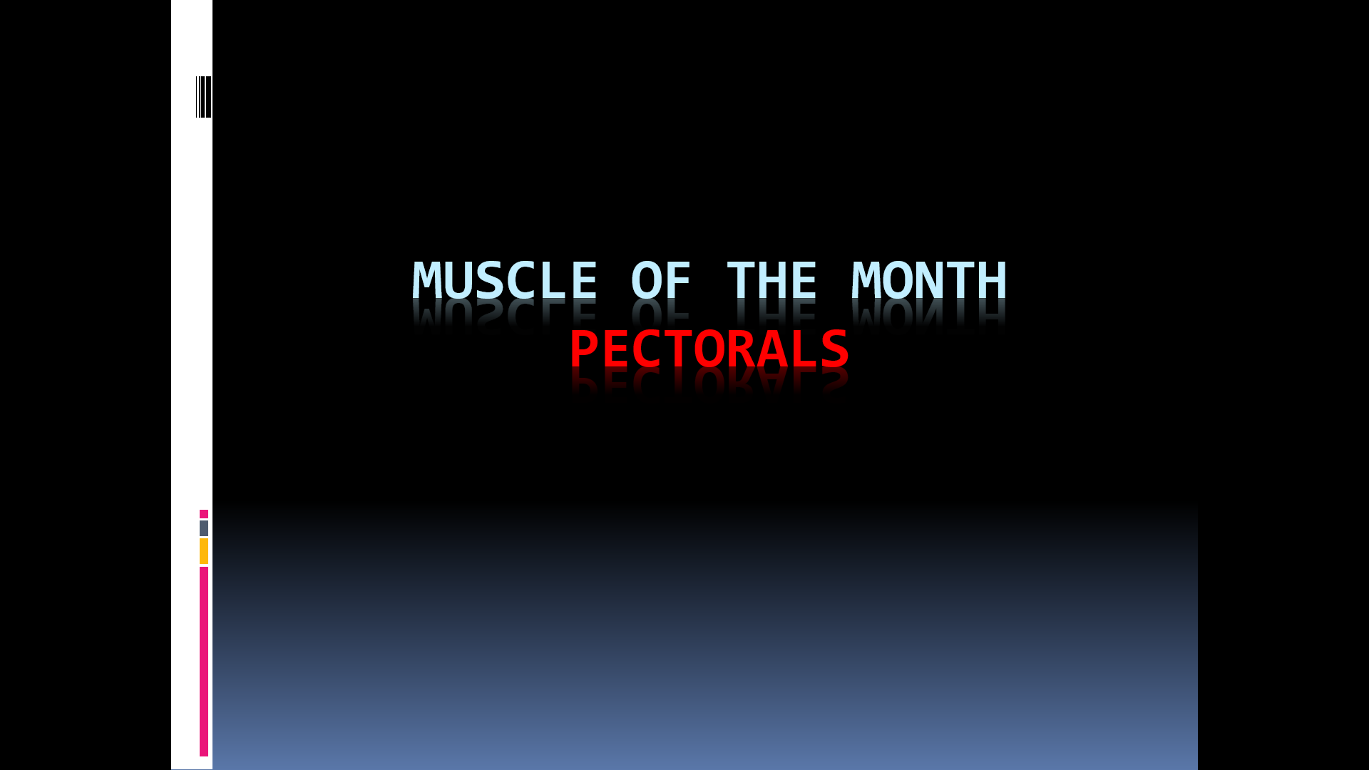

Function of the Pectorals
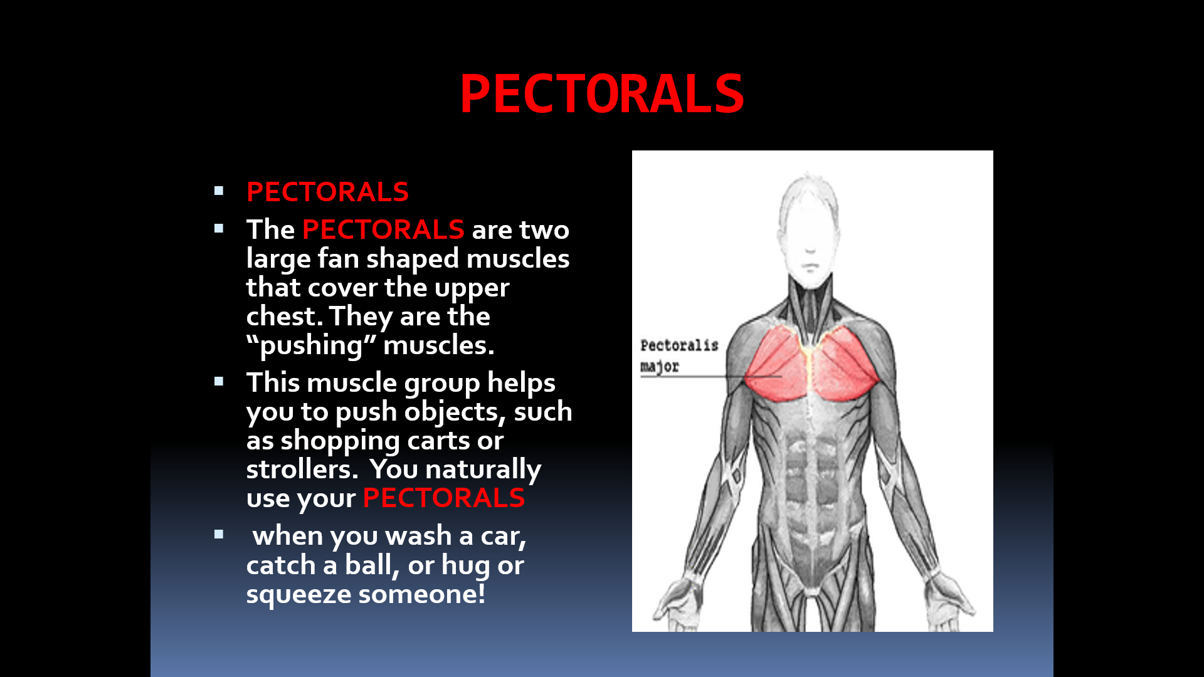
How do we use these muscles in PE?
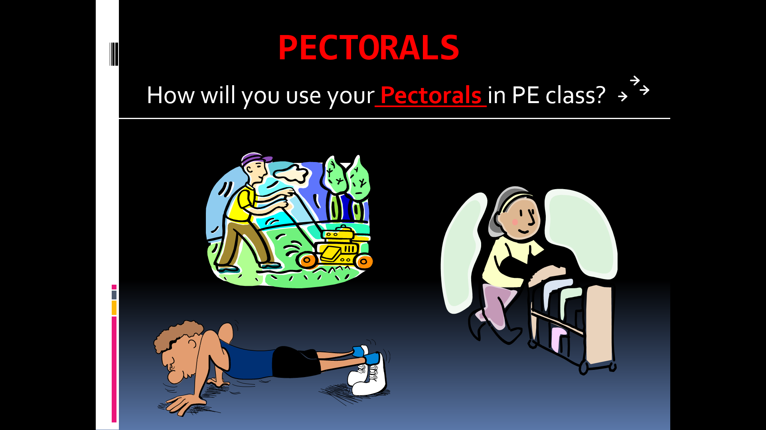
The Pectorals are used for muscular strength and muscular endurance in PE class.
